(Tabs) HOME, COVID-19 & BHT, HEALTH AND NUTRITION, POLITICS AND ECONOMICS, MORE

HEALTH AND NUTRITION Tab includes:

NUTRITION ESSENTIALS
PRIMITIVE VS WESTERN DIET
CANCER
DETERGENT VS SOAP
FACTORY FARMING
CHOLESTEROL
JOINT HEALTH
CATARACTS
ADDICTION RECOVERY
ALZHEIMER’S
PARKINSON’S DISEASE
MEDICAL CARE COST
VITAMIN SUPPLEMENTS

POLITICS AND ECONOMICS Tab includes:

INFLATION MADE SIMPLE
MORE INFLATION
ANTI-US GLOBALIZATION
FOREIGN AID-REGULATIONS
SOLUTIONS AND REFERENCES
PERPETUAL WAR
WAR ON ISLAM
THE WAR ON UKRAINE

MORE Tab includes:

ENVIRONMENTALISM HOAX
EARLY CHILDHOOD EDUCATION
BEING GAY

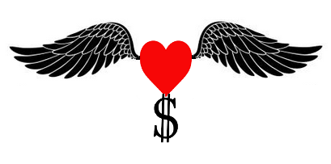
HEALTH FREEDOM WEALTH

MY YOUTUBE CHANNEL
https://www.youtube.com/channel/UCPj87XcaECEry5tJ8LONJzg

The National Debt Scam, below, has 978,000 views
https://www.youtube.com/watch?v=3qHL2NBmZqQ

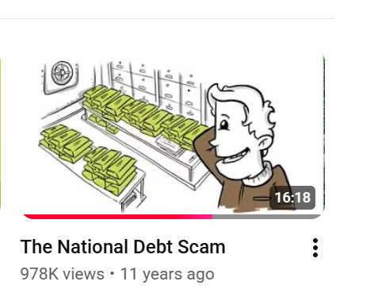
This video explains the evolution of the U.S. economy from a Natural Economy to an Artificial Economy. The Natural Economy allowed the U.S. to evolve from a frontier settlement to become the richest country in the world. However, in 1913 with the conversion to an Artificial Economy, there has been extreme boom and bust cycles, jobs shipped overseas, and overall economic decline. The American Dream is now a nightmare. Learn how it happened.

SEE COVID19 AND BHT TAB FOR PANDEMIC INFORMATION
INTRODUCTION
I put Health and Nutrition first because that is an area over which you have a great deal of control. Politics and Economics, not so much. Before Donald J. Trump, you got to chose between a Republican or Democrat brand of servitude that would harm you the least.

If you don't believe the above statement, see the tabs: ANTI-U.S. GLOBALIZATION and INFLATION MADE SIMPLE to understand that the destruction of the middle class economy started in 1914. With the passage of the Federal Reserve Act and the 16th amendment, the main revenue of the federal government gradually changed from the collection tariffs to the collection of income tax. Our competitive edge was not lost, it was slowly and steadily given away by lowering taxes on foreign production and increasing taxes on domestic production. Before President Trump, no politician or media report in the last 50 years, with their short term focus, has mentioned anything addressing this paradigm shift to manufacturing jobs lost.

Health and Nutrition is a wide open field.
In the sub tab: Primitive vs Western Diet How could the western diet cause genetic changes in primitive tribes in one generation? Learn about Dr. Weston Price and the MicroRNA Story.

In the sub tab: Cancer Cancer was once rare. Is there finally a CURE? The National Institutes of Health (at nih.gov) has several shocking reports. There actually appears to be a cure but learn why it will NEVER be FDA approved.

Also, learn about two hidden substances consumed daily by most people that have dramatically increased cancer rates in the last 50 years. Believe it or not they are detergent and antibiotics. See Detergent vs Soap and Factory Farming Problem.

In the sub tab: Cholesterol Statins, like Lipitor, can cause severe memory problems. It may not be dementia! The cholesterol problems in older people are typically due to lack of sunshine. Learn how to manage cholesterol without the severe side effects of statins which also include muscle pain and weakness.

In the sub tab: JOINT HEALTH I found a cure for eroded cartilage. 2 years after being diagnosed with painful osteoarthritis, I have been without pain and I am convinced that I will be able to avoid knee replacement surgery.

In the sub tab: Cataracts I discovered an eye drop that dissolves cataracts. The colors now look so vibrant and I can drive at night with no annoying glare. In addition, my vision with age went to 20:40 with astigmatism and is now back to 20:20 with no astigmatism!

In the sub tabs: Alzheimer's Parkenson's disease A research paper contends that the herpes virus responsible for cold sores also may cause Alzheimer's disease. Oral administered BHT cures herpes virus and also reduces the risk of Parkinson’s.

COVID-19 & BHT BHT is a potent anti-viral (I did not get Covid and do not need a yearly flu shot) but also prevents brain damage and reverses brain damage due to chronic alcohol abuse.

In the sub tab: Medical Care Cost Learn how the unforeseen consequence of one government regulation of insurance companies has resulted in the medical care cost crisis. In the 60's medical care used to be very affordable, even cancer surgery. Would you believe $243.75 total bill for my father's cancer surgery in 1962! See a copy of that bill.

As for Politics and Economics
In the sub tab: INFLATION MADE SIMPLE Find out why the Federal Reserve raised interest rates to fight inflation when low interest rates did not cause inflation. Why does the Federal Reserve not address the fundamental cause of inflation? Follow the money.

In the sub tab: INCOME-WEALTH INEQUALITY How can technology advance so dramatically resulting in increased worker productivity and yet the standard of living is decreasing especially for younger generations? The resulting frustration and conflict is at the heart of society's decline. Where is all of that increased wealth going?

In the sub tab: FOREIGN AID - REGULATIONS Why would the United States give billions of dollars in aid to almost every country in the world including Iraq, China, and even Russia? Unbelievable! https://www.foreignassistance.gov/

In the sub tab: Perpetual WAR Armies don’t make peace. They enrage adversaries and generate huge profits from the resulting perpetual wars. The War on Iraq caused over 200,000 civilians deaths by direct violence and the deaths of over 100,000 children due to starvation. It was based on a lie and made a formidable enemy out of the entire Muslim world creating millions of them outraged, armed, and not afraid to die. That outrage lead to the 9/11/2001 attack. That began the War on Terrorism that continues to this day. The War in Ukraine, instead of ending quickly, which could have easily been done, the war drags on and the money continues to flow. The United States has provided Ukraine with more than $111 billion of taxpayer's money since Russia's invasion with absolutely no accounting.

ENVIRONMENTALISM HOAX Is it all just a hoax? Yes it is and I can prove it with NASA satellite data! The earth has gotten greener in the last 20 years due to human activity. The extra carbon dioxide in the atmosphere, ~100ppm was also a factor. However, that was a change in the atmosphere of only 0.01%, One could expect the climate to also change by 0.01%.

Early Childhood Education has to do with both economics and health. I strongly recommend Glenn Doman's books "How To Teach Your Baby To Read" and "Teach Your Baby Math." If you start early, you will not only have a lot of fun but you will be shocked with what can be accomplished. My daughter read her first book at 24 months of age. I taught her cursive at 3 1/2 and she read her first adult novel "Santa Claus: The Movie" which was 244 pages at 4 1/2 years old. She was at the top of her class through college.

BEING GAY is not genetic. There is evidence of environmental factors that can feminize the brain of one identical twin but not the other.

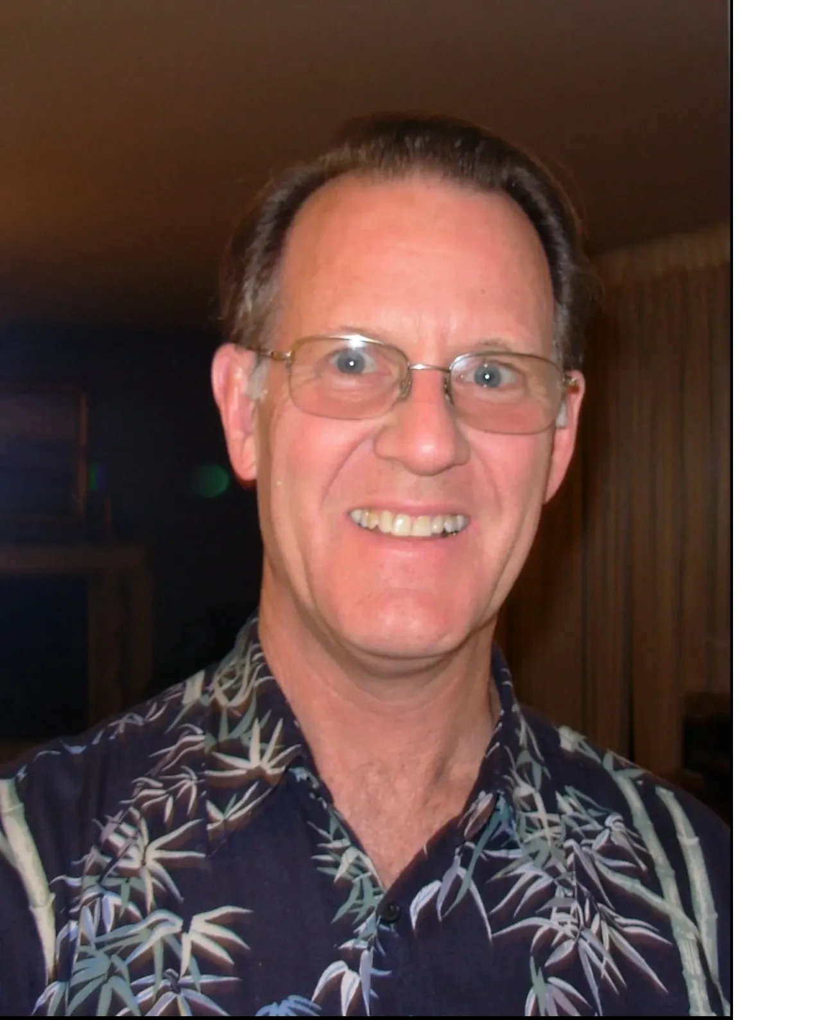
My name is Roy Ireland. I have been an electronic engineer for over 40 years. Back in the days of dial up modems and bulletin boards, I can remember asking a fellow engineer to explain the Internet to me. I could not grasp the concept and could not see any practical application. Since then the internet has evolved into an almost limitless source of information, some of it very valuable. I have uncovered some incredible insights on a variety of subjects including health and nutrition, cultural values, economics, and politics. I have accumulated so much information that I had to create this website to remove the temptation to overwhelm people with too much information. When meeting someone new, I did not want to leave anything out. I learned that what is exciting to me is not always exciting to others especially when they are the victim of information overload. Now I can peak their interest with just one or two tidbits, hand them my card and invite them to explore more.

